General Journal Posting: Details OR Summary level posting
In Journal Setup we have option for detail and summary level posting
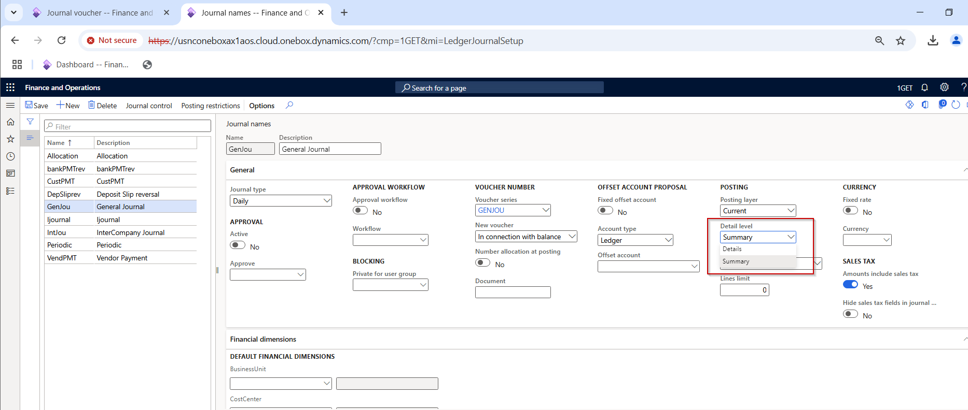

General Journal Entry
I posted a below entry in General Journal.
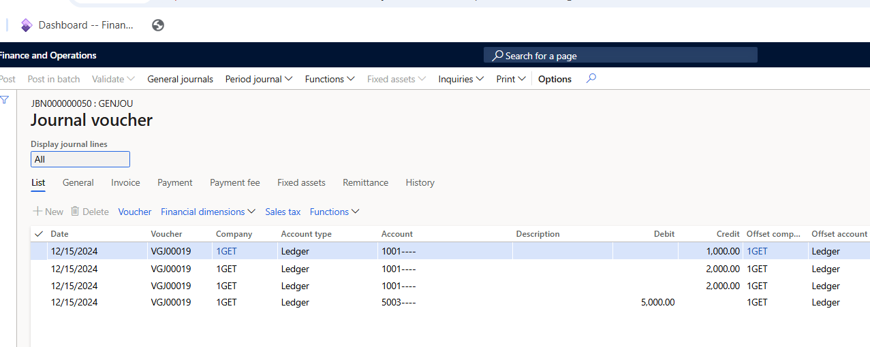

Summary Posting: A summation of journal lines into one transaction is performed automatically during posting if voucher with date, account number, dimension and currency code contain the same value.
After I posted the transaction, I saw the voucher details
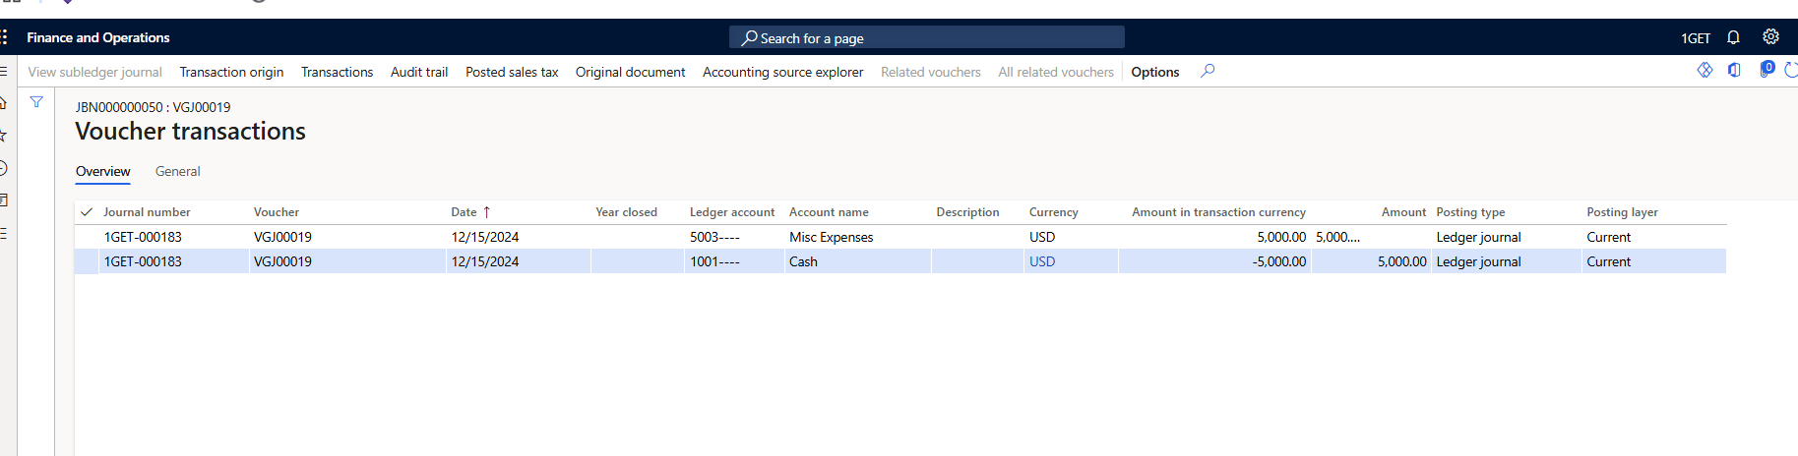

Details: Every instance of the account number in the journal lines is posted as separate account transaction.
After I posted the transaction, I saw the voucher details

